## DESIGN DOCUMENT

FOR

MATHEMATICS CHALLENGE SYSTEM

G-25

Supervisor: Mary Nsabagwa

|  |  |  |
| --- | --- | --- |
| **NAME** | **REGISTRATION NUMBER** | **STUDENT NUMBER** |
| ARYAMPA JOSHUA | 23/U/06517/PS | 2300706517 |
| NAMATA SUMAYYA | 23/U/22615 | 2300722615 |
| NAKAYE HILDAH | 23/U/13598/PS | 2300713598 |
| MUKYALA DORCUS NANDY | 23/U/11911/EVE | 2300711911 |
| MUSHABE MOSES | 23/U/12131/EVE | 2300712131 |

TABLE OF Contents

1. Introduction 5

1.1 Purpose 5

1.2 Scope 5

1.2.1 Goals, objectives and benefits 5

1.3 Document Overview 6

1.4 Reference Material 6

1.5 Definitions and Acronyms 7

1.5.1 Definitions 7

1.6 Acronyms 7

2. System Overview 8

3. System architecture 10

3.1 Architectural design 10

3.2 Decomposition Description 13

3.3 Design Rationale 18

4. Data design 18

4.1 Data description 18

4.2 Data dictionary 20

5. Component design 24

6. Human interface design 25

6.1 Overview of user interface 25

6.2 Screen images 26

6.3 Screen objects and Actions 30

7. Requirements matrix 31

List of figures

Figure 1 System Architectural Design 11

Figure 2 Mathematics Challenge System Use Case diagram 13

Figure 3 Student Registration activity diagram 14

Figure 4 Pupil Verification activity diagram 15

Figure 5 Challenge attempt activity diagram 16

Figure 6 Sequence diagram showing the process of pupil registration 17

Figure 7 Sequence Diagram showing the process leading to challenge attempt 18

Figure 8 Mathematics challenge system class diagram 19

Figure 9 Enhanced Entity Relationship Diagram for the system database 21

Figure 10 The interface used by the administrator to login into the system 28

Figure 11 The landing page of the International Education Services website 29

Figure 12 The registration page for uploading schools and their details into the system 30

Figure 13 The set challenge page to be used by the administrator to set challenge parameters 30

Figure 14 Command Line Interface that the student uses to register for the mathematics challenge 31

Figure 15 The Command Line Interface that the School Representative Uses to confirm applicants 31

List of tables

Table 1 Data Description table showing system entities and their attributes 19

Table 2 Data Dictionary for Answer table 21

Table 3 Data dictionary for Attempts table in the system database 22

Table 4 Data dictionary for Challenge table in the system database 22

Table 5 Data Dictionary for ChallengeAttempt table 23

Table 6 Data dictionary for Participant table in the system database 23

Table 7 Data Dictionary for Question table 24

Table 8 Data dictionary for School table in the system database 24

Table 9 Data dictionary for School Representative table in the system database 25

Table 10 System Entities and their methods 25

Table 11 Requirements matrix 34

# Introduction

## Purpose

This document outlines the architecture and system design for the mathematics competition web system for primary school children all over the country, organized by the International Education Services. It will be used to guide the development team during implementation and to facilitate discussions between stakeholders and the development team.

## Scope

The web system is for primary school children from registered schools nationwide to participate in a mathematics challenge organized by International Education Services.

### Goals, objectives and benefits

The system should facilitate the following actions:

* Allowing an administrator to upload schools and their details.
* Permitting a registered administrator to upload questions and answers.
* Randomly selecting questions from the uploaded questions for each attempt.
* Enabling the administrator to set parameters to open the competition.
* Allowing participants to log in and attempt the assignment.
* Sending a report of correct answers for all attempted questions to all participants at the close of the challenge.
* Recognizing the first two winners.
* Registering participants.
* Allowing participants to view challenges.
* Allowing school representatives to log into the system to confirm or reject new participants.
* Grading participants for each attempted question.
* Issuing a report and score to the participants after the attempt.
* Providing analytics for the mathematics challenge.

## Document Overview

The document is organized into the following chapters:

Chapter 1: Introduction

Purpose and overview of the document and scope of the system are identified.

Chapter 2: System Overview

General description of the functionality, context, and design of the mathematics challenge web system is provided.

Chapter 3: System Architecture

Architectural design, decomposition description, and the design rationale are specified.

Chapter 4: Data Design

Data description and data dictionary of the system are contained in this chapter.

Chapter 5: Component Design

A systematic analysis of each component's functionality is provided.

Chapter 6: Human Interface Design

Focuses on the user interface and user experience.

Chapter 7: Requirement’s Matrix

Provides a cross-reference that traces components and data structures to the system requirements.

## Reference Material

J. Burge, J. Carroll, R. McCall, and I. Mistrík. Rationale-Based

Software Engineering. Springer-Verlag, 2008.

L. Bass, P. Clements, and R. Kazman. Software Architecture in

Practice 2nd ed. Addison Wesley, 2003

## Definitions and Acronyms

### Definitions

Activity Diagram: Depicts the flow of activities among different actors in the system.

Use Case Diagram: Summarizes the system's details and the users within it.

Entity Relationship Diagram: Offers a visual representation for initiating the database design.

Sequence Diagram: Illustrates the sequence of messages exchanged between system objects.

## Acronyms

SDD: Abbreviation for Software Design Document

ERD: Stands for Entity Relationship Diagram

# System Overview

The system is created to efficiently manage and streamline the entire process of a mathematics competition, making it user-friendly for administrators, school representatives, and participants. It includes both web and command line interfaces to cater to the different aspects of the competition. Administrators are responsible for uploading schools, questions, challenges, and overseeing the overall competition. School representatives verify and confirm participants from their schools, while participants register and attempt challenges using a command line interface, keeping the focus on the core competition activities. An administrator can upload school details such as name, district, registration number, email and representative's name into the system. A registered administrator can upload a set of questions, corresponding answers, and marks from Excel documents. For each attempt, a random selection of questions is used from the uploaded pool for example 10 questions from a pool of 100 questions. The administrator sets parameters for each challenge, including start and end dates, duration, and the number of questions. Once the challenge is open, participants can attempt it within the specified dates. After completing a challenge, each participant receives an email with a PDF report of the correct answers to all attempted questions. Participants register via a command line interface, providing personal and school details. They can view available challenges and choose which ones from among the valid ones to participate in, with each challenge allowing up to three attempts, and questions are presented randomly each time. If the school details entered by the participants do not match registered school details, they are informed. Otherwise, the record is added to a file, and an email notification is sent to the respective school representative to confirm the applicant. School representatives log into the system via the command line interface to confirm the newly registered participants. In the event that a participant is rejected, they are deleted from the file and moved into a database table **rejected** while those that accepted are deleted from the file and moved into the **participant table** in the database. For all cases, an email notification is sent to the applicants. An applicant is denied from registering under a school and informed on the command line interface in case they are trying to register again under the same school after being rejected. Accepted prospective participants can log into the system and attempt a challenge during which they can see questions one by one along with the remaining time and question count. Scoring is immediate with a deduction of 3 marks for a wrong answer, 0 marks for uncertain responses and awarded marks allocated for a particular question for a right answer. Participants receive immediate feedback on their performance after each attempt.

The system consists of two interfaces, the web interface for participants, school representatives, and administrators, and the command line interface for carrying out transactions. The system database stores information about schools, participants, challenges, questions, and results. The system is divided into three main modules: the registration module, the challenge management module, and the scoring and feedback module.

# System architecture

## Architectural design

**Modular program structure**

* School registration module

This module supports uploading schools and their details into the database by the administrator

* Challenge management module

This allows the registered administrator to upload questions and answers from the excel documents as well as setting parameters required to open the competition.

* Challenge attempt and scoring module

This supports the random selection of questions for the participant to attempt, awarding of marks and generating a report.

* Feedback module

This module supports posting the first two participants on the website, sending emails to participants containing a pdf report of right answers for all attempted questions and analytics

* Pupil registration module

This allows pupils to register themselves with personal and school details into the database

* Pupil verification module

This allows the school representative to confirm the registered students thereby transferring them into the appropriate table in the database

* Database management module

Stores data and information about school participants and school representatives

**Major subsystems**

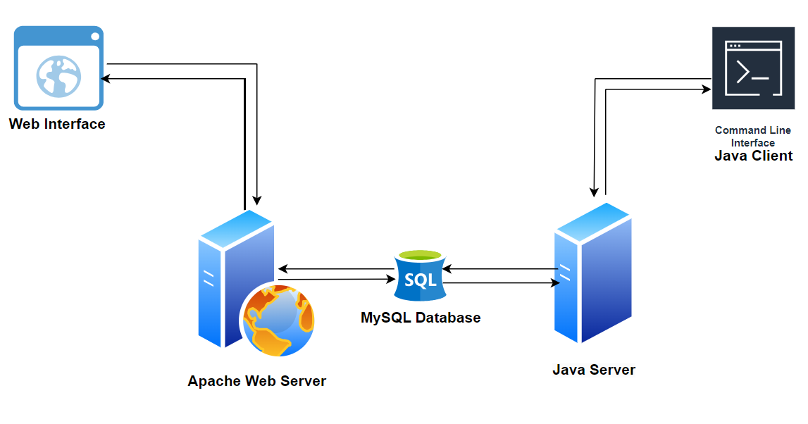

Figure 1 System Architectural Design

* Web Interface

The platform on which the registered administrator uploads two excel documents, one for the questions and the other for answers and their corresponding marks. It’s also the platform on which the first two winners are posted and schools are uploaded by the administrator.

* Apache Server

It contains the application logic that controls the web client’s access to the database. It also houses the systems web documents such as html, CSS and JavaScript files

* Java Client

This provides a platform for pupils to register, login and attempt the challenges and school representatives to login and confirm participants.

* Java Server

It contains the application logic that controls the java client’s access to the database. It also houses the file where applicants’ information is held before confirmation by the school representative.

* Database

It is a collection of tables containing information about schools, school representatives and participants

## Decomposition Description

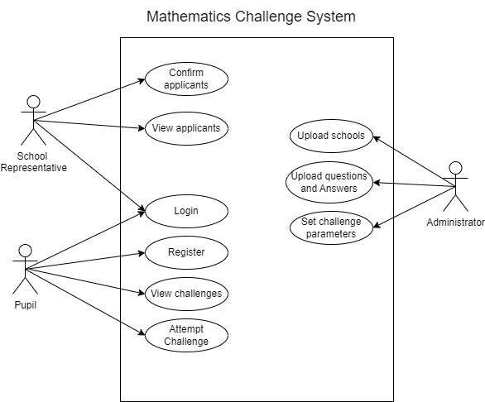

Figure 2 Mathematics Challenge System Use Case diagram

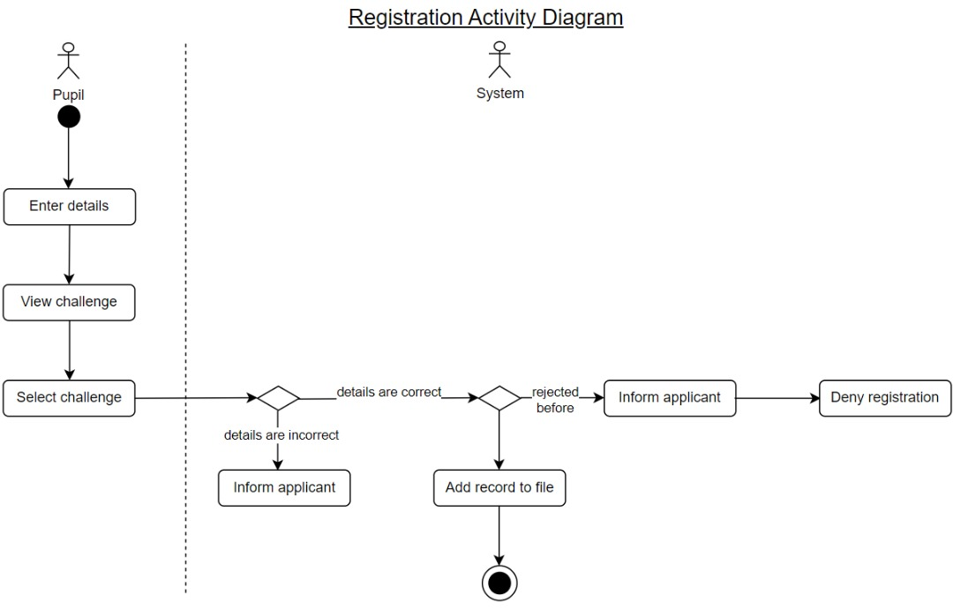

Figure 3 Student Registration activity diagram

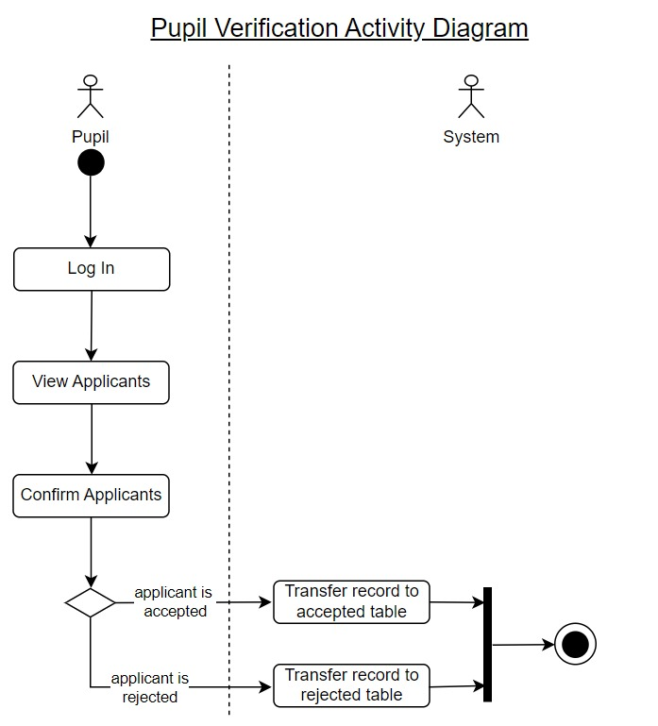

Figure 4 Pupil Verification activity diagram

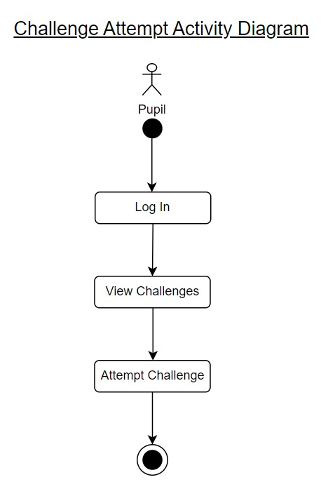

Figure 5 Challenge attempt activity diagram

Sequence diagram for pupil registration

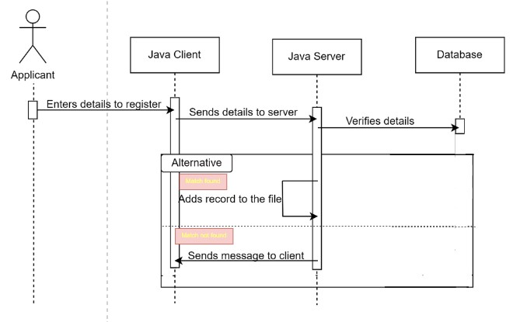

Figure 6 Sequence diagram showing the process of pupil registration

Sequence Diagram for Challenge Attempt

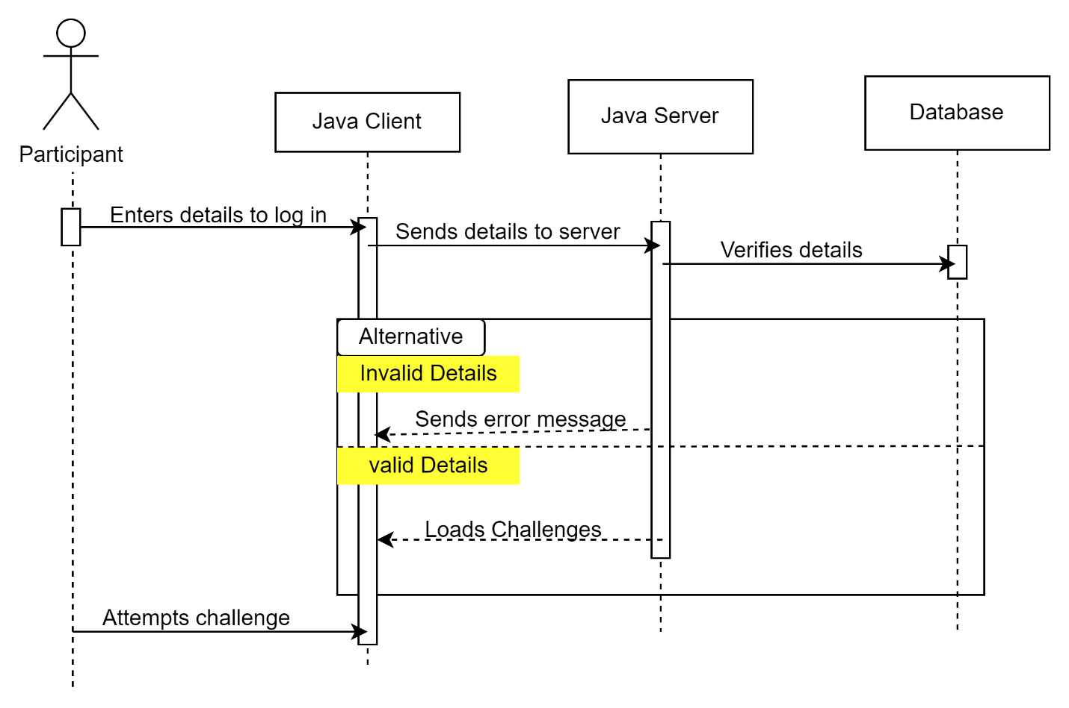

Figure 7 Sequence Diagram showing the process leading to challenge attempt

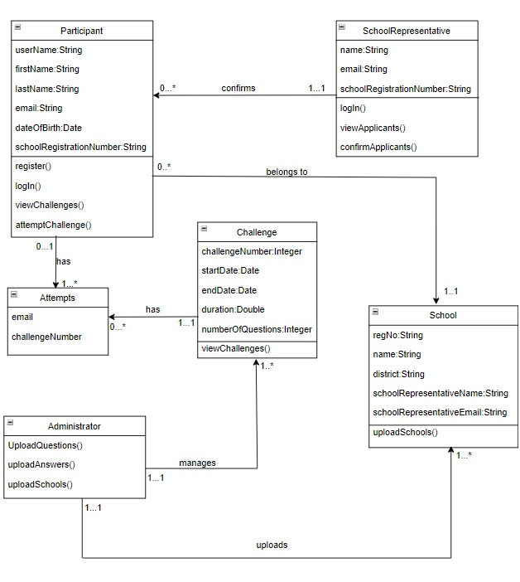

Figure 8 Mathematics challenge system class diagram

## Design Rationale

The architecture of the choice for the system is the layered architectural pattern. This type of architecture divides the system into layers with each layer containing components that provide a particular service. We chose this architectural pattern mainly because of its maintainability and testability. Maintenance can be done on each layer independent of other layers and testing can be done layer by layer easing the process of finding and addressing bugs.

# Data design

## Data description

Table 1 Data Description table showing system entities and their attributes

|  |  |
| --- | --- |
| Entity | Attribute |
| School | RegNo (PK)  Name  District  SchoolRepresentativeName  SchoolRepresenativeEmail |
| Accepted Participant | Email (pk)  RegNo (fk)  UserName  FirstName  LastName  DateOfBirth |
| Rejected Participant | Email (pk)  RegNo (fk)  UserName  FirstName  LastName  DateOfBirth |
| Challenge | ChallengeNo (pk)  OpenDate  CloseDate  Duration |
| Attempts | Email (pk)(fk)  ChallengeNo (pk)(fk) |

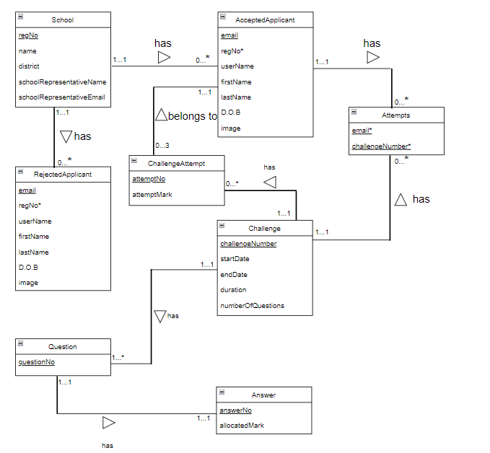

Figure 9 Enhanced Entity Relationship Diagram for the system database

## Data dictionary

Answer

Table Data Dictionary for Answer table

|  |  |  |  |  |
| --- | --- | --- | --- | --- |
| ATTRIBUTE | DATA TYPE | SIZE | KEY | DESCRIPTION |
| answerNo | INT | 120 | PRIMARY KEY | Unique identifier for a given Answer |
| allocatedMark | INT | 3 |  | Mark awarded for an answer |

Attempts

Table 3 Data dictionary for Attempts table in the system database

|  |  |  |  |  |
| --- | --- | --- | --- | --- |
| ATTRIBUTES | DATATYPES | SIZE | KEY | DESCRIPTION |
| email | VARCHAR | 25 | PRIMARY KEY  FOREGIN KEY | Unique identifier and reference to participant table |
| challengeNumber | INT | 15 | PRIMARY KEY  FOREGIN KEY | Unique identifier and reference to Challenge table |

Challenge

Table 4 Data dictionary for Challenge table in the system database

|  |  |  |  |  |
| --- | --- | --- | --- | --- |
| ATTRIBUTES | DATA TYPES | SIZE | KEY | DESCIPTION |
| challengeNumber | INT | 15 | PRIMARY KEY | Unique identifier for a challenge |
| startDate | DATE |  |  | Starting date of the challenge |
| endDate | DATE |  |  | Ending date of the challenge |
| duration | DECIMAL | 120 |  | Allowable time for the challenge |
| numberOfQuestions | INT | 15 |  | The number questions in the challenge |

ChallengeAttempt

Table Data Dictionary for ChallengeAttempt table

|  |  |  |  |  |
| --- | --- | --- | --- | --- |
| ATTRIBUTE | DATA TYPE | SIZE | KEY | DESCRIPTION |
| attemptNo | INT | 120 | PRIMARY KEY | Unique identifier for a given ChallengeAttempt |
| attemptMark | INT | 100 |  | Sum of question scores for a given attempt |

Participant

Table 6 Data dictionary for Participant table in the system database

|  |  |  |  |  |
| --- | --- | --- | --- | --- |
| ATTRIBUTES | DATA TYPES | SIZE | KEY | DESCIPTION |
| userName | VARCHAR | 15 |  | Participants user name |
| firstName | VARCHAR | 15 |  | Participants first name |
| lastName | VARCHAR | 15 |  | Last name of the participant |
| email | VARCHAR | 25 | PRIMARY KEY | Unique identifier for participant |
| dateOfBirth | DATE |  |  | Date of birth of the participant |
| schoolRegNumber | VARCHAR | 15 | FOREIGN KEY | School registration number references school table |

Question

Table Data Dictionary for Question table

|  |  |  |  |  |
| --- | --- | --- | --- | --- |
| ATTRIBUTE | DATA TYPE | SIZE | KEY | DESCRIPTION |
| questionNo | INT | 100 | PRIMARY KEY | Unique identifier for a given Question |

School

Table 8 Data dictionary for School table in the system database

|  |  |  |  |  |
| --- | --- | --- | --- | --- |
| ATTRIBUTES | DATA TYPES | SIZE | KEY | DESCIPTION |
| Reg number | VARCHAR | 15 | PRIMARY KEY | Unique identifier for a school |
| name | VARCHAR | 25 |  | Name of the school |
| district | VARCHAR | 15 |  | District of the school |
| schoolRepresentativeName | VARCHAR | 25 |  | Name of the school representative |
| SchoolRepresenativeEmail | VARCHAR | 25 |  | Email of the school representative |

Score

|  |  |  |  |  |
| --- | --- | --- | --- | --- |
| ATTRIBUTES | DATA TYPES | SIZE | KEY | DESCRIPTION |
| challengeNumber | INT | 15 | PRIMARY KEY | Uniquely identifies the score and references the challenge |
| score | INT | 3 | PRIMARY KEY | Uniquely identifies the score |

School Representative

Table 9 Data dictionary for School Representative table in the system database

|  |  |  |  |  |
| --- | --- | --- | --- | --- |
| ATTRIBUTES | DATA TYPES | SIZE | KEY | DESCIPTION |
| name | VARCHAR | 15 |  | Name of the school representative |
| email | VARCHAR | 25 |  | Email of the representative |

Entities and methods

Table 10 System Entities and their methods

|  |  |
| --- | --- |
| ENTITY | METHODS |
| Administrator | uploadQuestions  uploadAnswers  uploadSchools |
| Challenge | viewChallenge |
| Participant | register  login  viewChallenge  attemptChallenge |
| school | uploadSchools |
| SchoolRepresenative | logIn  viewApplicant  confirmApplicant |

# Component design

**Participant**

Step 1: The participant **registers** for the challenge by providing his/her username, firstname, lastname, emailAddress, school_registration_number and image_file.png

Step 2: The participant **views challenges** and chooses which competition they wish to participate in

Step 3: The participant **logs** into the system by entering the username, email and school registration number

Step 4: The participant **views challenges**

Step 5: the participant **attempts** the challenges by specifying the challenge number

**School representative**

Step 1: The school representative **logs** into the system by specifying the name, email and registration number

Step 2: The school representative **views participants**

Step 3: The school representative **confirms participants** by entering username and yes or no

**Administrator**

Step 1: The Administrator **uploads** **schools** into the system by entering the name, district, school registration number, email of the representative, name of the representative

Step 2: The administrator **uploads excel documents**

# Human interface design

## Overview of user interface

**Participant**

The participant will be required to use the command line interface to type any necessary commands they wish to execute such as register command, viewChallenges command and the attemptChallenge command. The viewChallenges command displays the available challenges on the screen. The attemptChallenge command presents the challenge interface to the participant.

**School Representative**

The School Representative types commands such as login, viewApplicants and confirm into the command line interface to verify the applicants.

**The Administrator**

The administrator uses the Web interface to upload schools and their details as well as question and answer excel documents using visual elements on the Graphical User Interface.

The administrator also uses the web interface to view the first two participants.

## Screen images

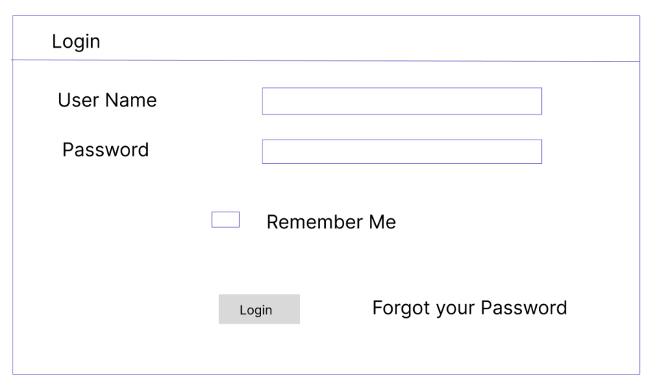

Figure 10 The interface used by the administrator to login into the system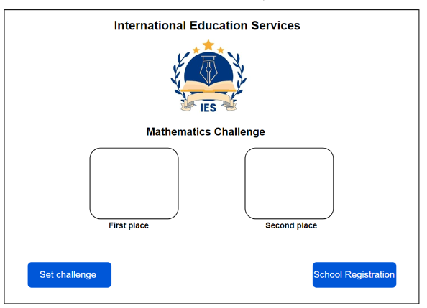

Figure 11 The landing page of the International Education Services website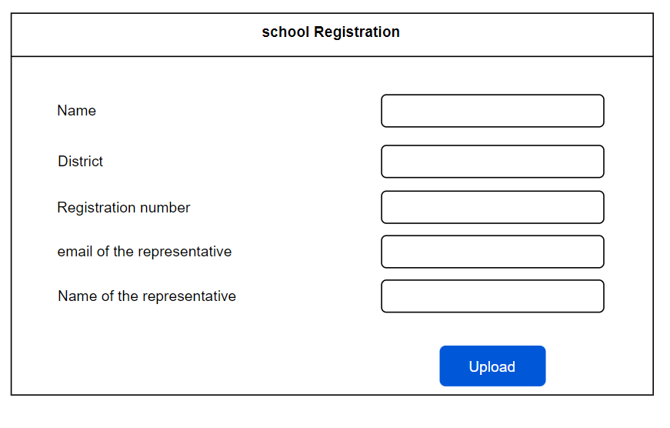

Figure 12 The registration page for uploading schools and their details into the system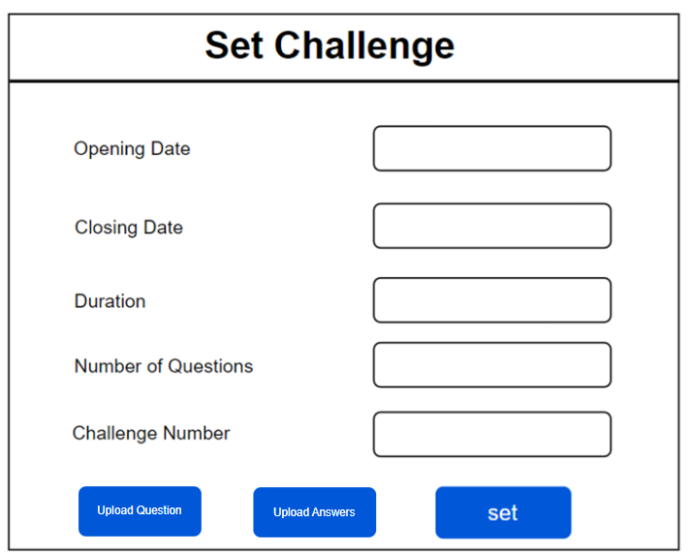

Figure 13 The set challenge page to be used by the administrator to set challenge parameters

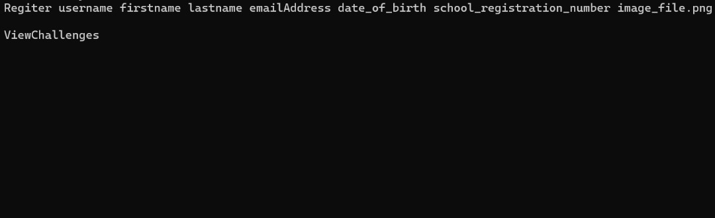

Figure 14 Command Line Interface that the student uses to register for the mathematics challenge

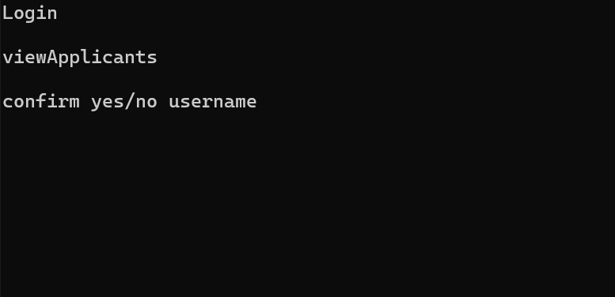

Figure 15 The Command Line Interface that the School Representative Uses to confirm applicants

## Screen objects and Actions

**Login form and login button**

The login form allows the administrator to enter his/her details and the login button allows the submission of the details for authentication

**Set challenge button**

This button redirects the administrator to the set challenge form

**Set challenge form, Upload question and upload answer and set button**

This form allows the administrator to set parameters for a given challenge and the set button allows submission of the set parameters.

The upload question and upload answer buttons allow the administrator to upload excel documents containing questions and answers respectively

**School registration button**

This redirects the administrator to the school registration form

**School registration form and upload button**

This form allows the administrator to upload schools and the upload button allows the contents of the form to be stored in the database

# Requirements matrix

Table 11 Requirements matrix

|  |  |  |  |
| --- | --- | --- | --- |
| ReqID | Functional requirement | System component | Data structures |
| R001 | School registration | School Registration Module | Tables |
| R002 | Question and answer  upload | Challenge Management module | Excel sheets |
| R003 | Setting parameters | Challenge Management module | Tables |
| R004 | Pupil registration | Pupil registration module | File |
| R005 | Participant confirmation | Pupil Verification module | Table |
| R006 | Challenge attempt | Challenge Attempt and Scoring Module | Excel sheets |
| R007 | Report analytics | Feedback module | Tables |